# CS 255 System Design Document Template

This template lays out all the different sections that you need to complete for Project Two. Each section has guidance to prompt your thinking. You will need to continually reference the interview transcript as you work to make sure that you are addressing your client’s needs. There is no required length for the final document. Instead the goal is to complete each section based on what your client’s needs are. Remove this note when you are finished, and replace all bracketed text with the relevant information.

## UML Diagrams

### UML Use Case Diagram

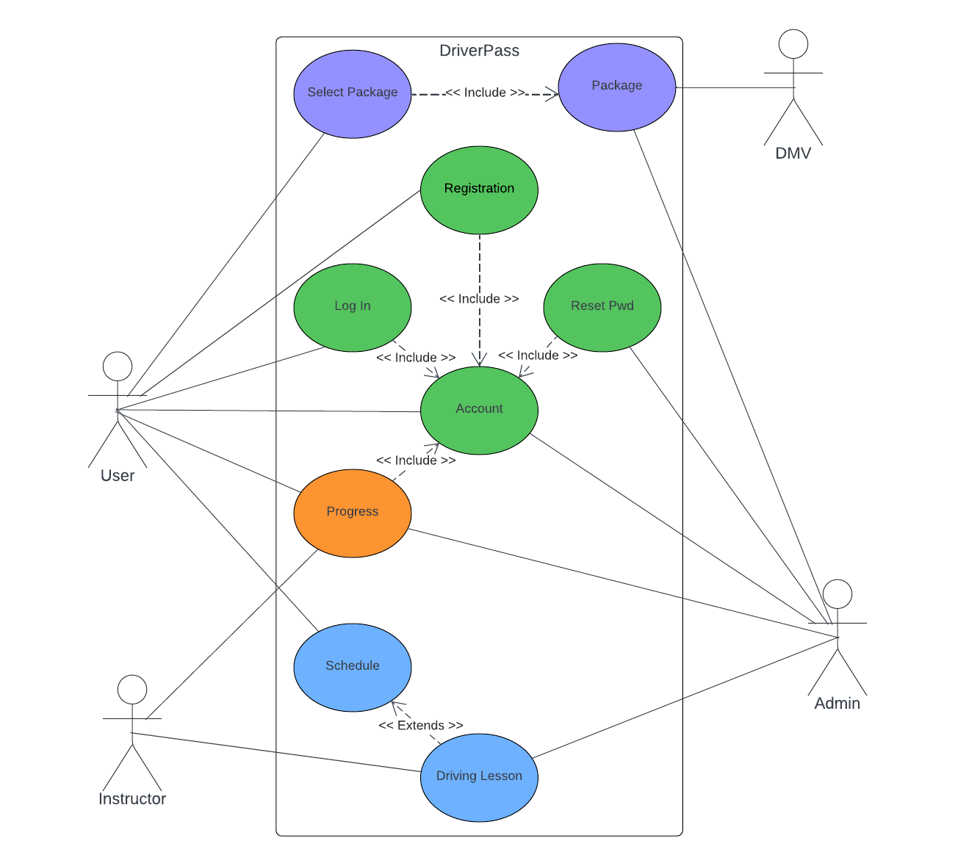

### UML Activity Diagrams

### UML Sequence Diagram

Scheduling

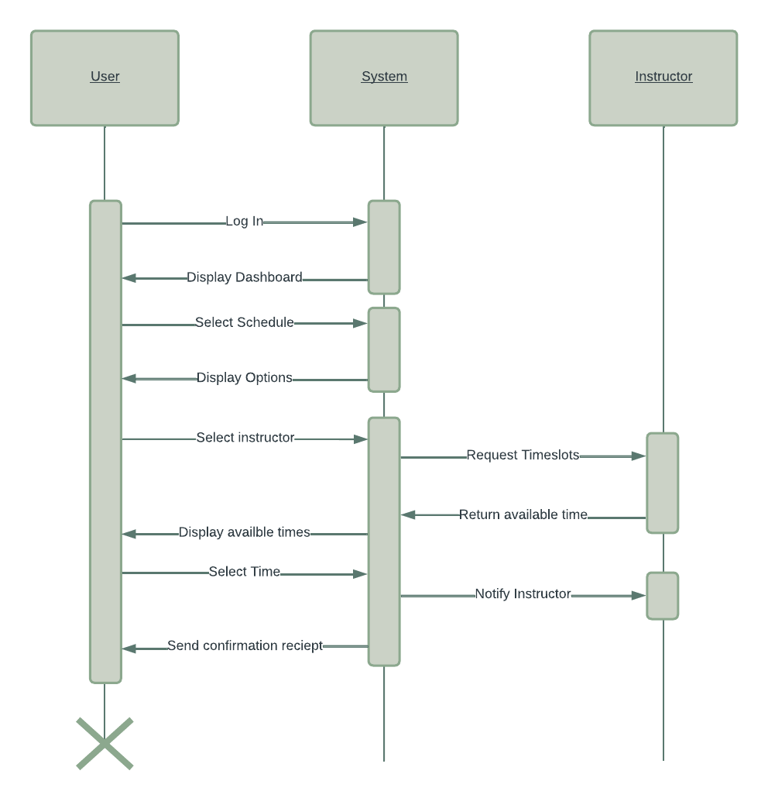

### UML Class Diagram

Progress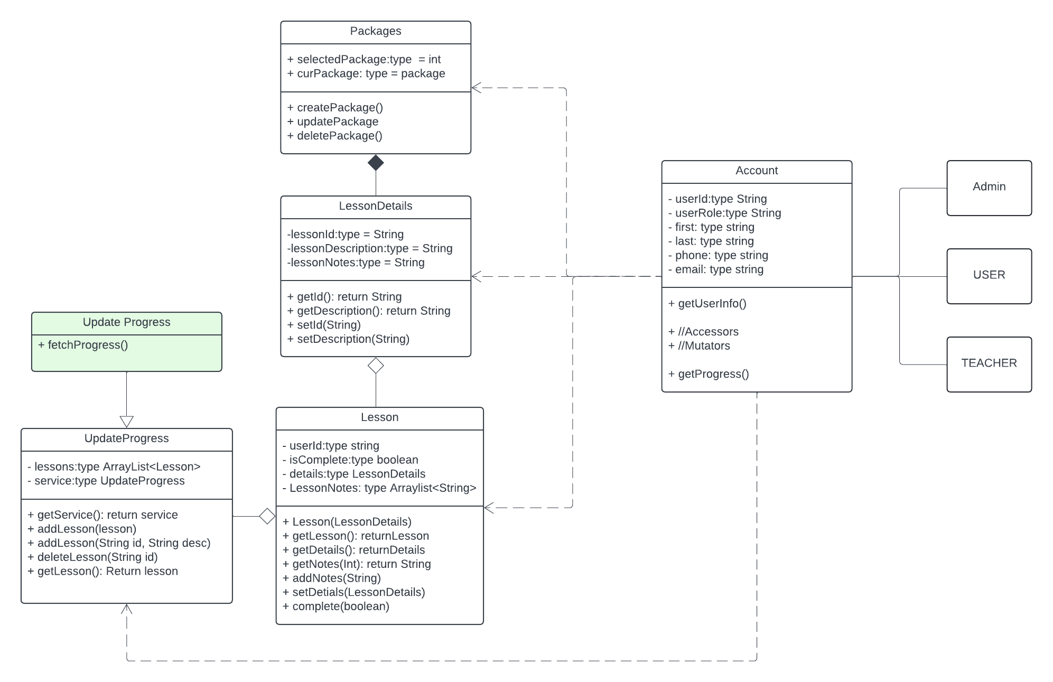

## Technical Requirements

**Hardware:**

* Servers: for hosting the DriverPass program
* Databases: For storing data, Account information, user data, lesson details, packages, progress info.
* Network: For communicating between servers and clients.

**Softwares:**

* Operating system: The server will need to run on an operating system such as linux or windows server.
* Web Server: Web servers like Apache and NGINX are used to run the website so users can view the web pages.
* DBMS: The server will need to store data using a database system such as MySQL or MongoDB.
* Programming Languages: The system will need to use a flavor of programming language such as Java, Python or PHP for the backend and HTML, CSS and Javascript for the front end.
* Frameworks: depending on our programming language of choice we can utilize frameworks to help our development. Spring (Java), Django (Python) or even Laravel (PHP). These can help us to create secure interfaces to our system.

**Tools**

* IDE’s: IDEs like VSCode, Intelij, Eclipse are great tools for boosting performance when it comes to writing code.
* Project Management Tools: A tool like Jira or Asana can help development teams to coordinate and communicate work. This helps to improve the structure of the team and boost their performance.
* Source Control tools: A source control tool such as git can help developers to review, manage and build software.
* Testing: A testing tool such as Junit can help the team with testing their code before it is pushed to the live system. This can help to track down any bugs before they are accessible to the community.

Infrastructure:

* Cloud platforms: As requested by the requirements of the driverpass system, we will need to use a cloud platform. They will be used both for hosting the website and storing our databases. Our team will be able to modify the system using our local computers and sending updates to the system remotely.